# Formula Student—Week 2

Approach research:

1. Traditional object detection

We found an algorithm about object detection from a book called Computer Vision.

1. Fast-RCNN

Searching on the Internet, we find there is a mature object detection algorithm based on neural network— RCNN, and in the meanwhile a lot of algorithms related to RCNN have developed and used widely. After comparing the efficiency of each algorithm, we try to use fast-RCNN to detect cones.

Problem: The configuration of tensorflow was so complicated even though we have found the way to train our model with fast-RCNN. We were stuck into some installing errors for long which was not productive. Finally, we decided to use YOLOv3 which worked well with other students to finish our task.

1. YOLOv3

Introduction: You only look once (YOLO) is a state-of-the-art, real-time object detection system. Different with traditional object detection method or RCNN using sliding windows, YOLOv3 apply a single neural network to the full image. This network divides the image into regions and predicts bounding boxes and probabilities for each region. These bounding boxes are weighted by the predicted probabilities. So YOLOv3 is faster than RCNN and traditional methods surely.

Disadvantage: YOLOv3 is not as accurate as RCNN sometimes and easy to have some location errors.

Advantage: Darknet which YOLOv3 is based on is easy to install and configure. The tutorial in official YOLO website is friendly for us to use our own pc to follow.

Procedure:

1. Create our own training dataset like VOC2007 using lebalImg. We chose 60 images from different videos and 45 were for train dataset and 15 were for test dataset.
2. Convert the xml files into darknet txt file format
3. Install darknet framework and make the configuration like modifying Cfg for Pascal Data or pointing out the train dataset directory
4. Train our own YOLO model with 3 classes: red_cone, yellow_cone, blue_cone. The training process took 4 hours or around with 10000 iterations.
5. Test our trained model with other dataset and check the behavior and accurancy of each class.

Here is some screenshot of our test result:

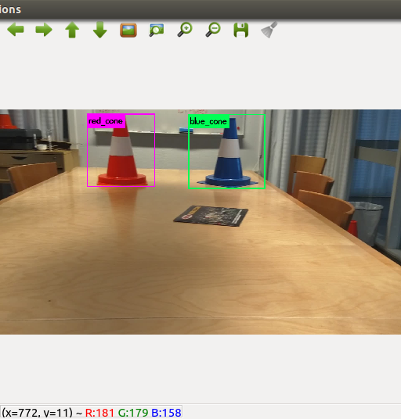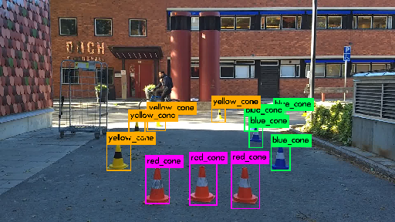

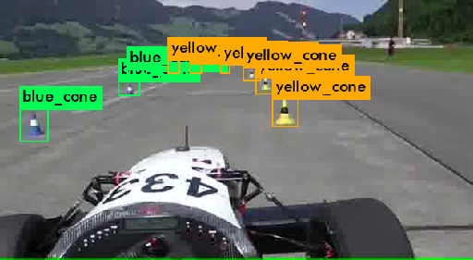

Future work:

We are going to research on the concept of YOLOv3 algorithm and understand more detail about it. Next step is trying to use YOLO model we trained to process live videos, and furthermore combine it with ROS system.